RUTH STRAUSS FOUNDATION
JOB DESCRIPTION

Job Title: Partnerships Manager
Salary: Commensurate with experience
Responsible to: Head of Fundraising, Ruth Strauss Foundation
Accountable to: Board of the Ruth Strauss Foundation
Hours per week: Five days per week
Location: Home based to begin with, then office based (Lord’s Cricket Ground NW8) when the ground re-opens subject to Covid-19. May require some travel to meet partners and attend events
Ruth Strauss Foundation
Early 2018, Ruth Strauss, wife of Sir Andrew Strauss the former England cricket captain, was diagnosed with an incurable lung cancer that affects non-smokers. Ruth died on December 29th 2018; she was 46 years old and mother to two children, then aged 10 and 13.

In her memory, Sir Andrew has launched The Ruth Strauss Foundation to:
- Provide emotional support for families to prepare for the death of a parent from cancer
- Raise awareness of the need for more research & collaboration in the fight against non-smoking lung cancers.
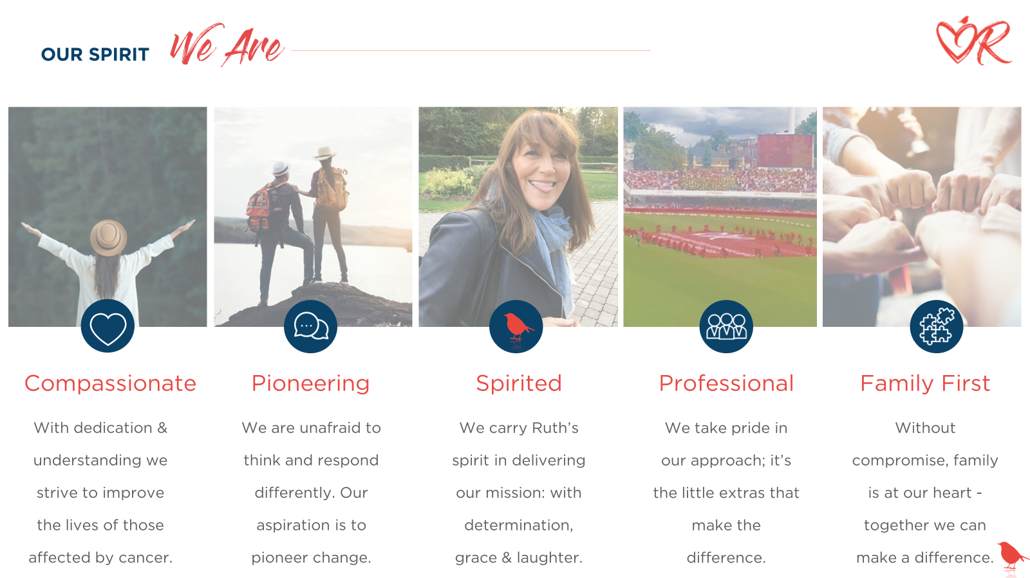
Job Purpose
We are recruiting for a Partnerships Manager to join our Fundraising team.
We have recently developed our fundraising strategy and secured support to invest in high-value fundraising from corporate and other partnerships. Our ambition is to secure and retain corporate partners, both long-term and high value. The Partnerships Manager will play a vital role in developing our approach and ensuring that both current and new partners are passionate about fundraising and aware of how valuable their support is.
Part of a small team, you will develop and manage a portfolio of relationships with a group of corporate partners and lead on both account management and securing new business, in the form of sponsorship and other funding, and have a solid understanding of best practice in corporate fundraising.

Key relationships
- Head of Fundraising of the Ruth Strauss Foundation
- Executive Team of the Ruth Strauss Foundation
- Foundation Partners and Prospects
- Board and Fundraising Advisory Group of the Ruth Strauss Foundation

Role Profile and Key Responsibilities
Develop approach to partnerships fundraising and the processes required to effectively support these partnerships.
- Lead on pitches for and secure new partnership opportunities
- Maximise planned income from partners, exploiting their fundraising potential and retaining accounts.
- Generate new income, working proactively to strategically grow these key relationships
- Develop and, with the wider Fundraising Team, implement a focused calendar of fundraising activities and activation stewardship opportunities specifically for Partners.
To achieve these objectives the post holder will be expected to:
- Provide exceptional account management for partners, ensuring they achieve targets and objectives.
- Develop and deliver robust partnership plans, maximise income generation and provide strategic direction for growth within each account.
- Generate income through a diverse fundraising mix - including employee fundraising, events, cause related marketing, payroll giving.
- Work with RSF stakeholders to support the identification of new opportunities and research and qualify new prospects
- Implement a calendar of activities for partners and develop new activations to boost engagement
- Ensure that evaluation and reporting on the impact of partnerships takes place in a timely manner.
- Maintain accurate budget and forecast figures for each corporate partner, supporting the Head of Fundraising with budgeting, phasing, and reforecasting of income.
- Manage and organize production of compelling materials for bespoke campaigns and work closely with colleagues to ensure RSF campaigns are integrated into our partners’ plans.
- Draft agreements and contract content for partners at all levels
- Use the (Salesforce) CRM system to build your pipeline and account management plans, and record all contact touchpoints and documents in a compliant manner
- Ensure that record keeping is efficient and effective, inputting relationship and contact details on to the database, and ensuring records remain up to date and accurate.
- Stay abreast of developments in fundraising from the corporate sector

What we are looking for:
In addition to someone who can embody the spirit of the RSF, you should also have the following skills and experience:
- Experience of working in corporate partnerships / CSR / marketing / sales
- Experience of working on Charity of the Year partnerships or generating income through creative corporate fundraising activations.
- Experience of business development and pitching
- Budget management experience
- Ability to influence, persuade and negotiate using interpersonal skills with various stakeholder types
- Competent user of Microsoft Word, Excel and PowerPoint and experience of client / supporter databases
- Confident and self-assured with creative flair and innovative approach to work
- A willingness to adapt and be flexible. There are often new projects, changing priorities, and new processes that you will need to embrace.
- Motivated by achieving targets, managing multiple tasks, and working to deadlines
- Ability to undertake travel, including overnight stays
Desirable
- Experience of working with HNWIs and/or grant-giving bodies
- Familiar with the Institute of Fundraising codes of practice

How to apply:
We are committed to being an inclusive workforce that fully represents many different cultures, backgrounds and viewpoints. We welcome applications that help us in our mission to be a place where you can be yourself and thrive.
Please send your CV and covering letter to Rosie Ranganathan by 4th January 2021. rosie.ranganathan@ruthstraussfoundation. com
Our intention is to interview shortlisted applicants via zoom week on 17th or 18th December 2020 with a view to appoint the successful applicant by late December 2020, subject to availability.
If you have any queries on this role, please contact Rosie Ranganathan rosie.ranganathan@ruthstraussfoundation. com
END

