RUTH STRAUSS FOUNDATION
JOB DESCRIPTION

Job Title: Designated Safeguarding Lead (6-month Fixed term Contract)
Salary: £30k (Pro rata - £16.50 per hour)
Responsible to: Head of Mission
Accountable to: Strategic Safeguarding Lead
Hours per week: 10 hours per week for initial 3 months, hours to be reviewed at 3 mths.
Location: Home based with occasional travel to events. RSF office location is Lord’s Cricket Ground, London, NW8.
Ruth Strauss Foundation
In early 2018, Ruth Strauss, wife of Sir Andrew Strauss the former England cricket captain, was diagnosed with incurable lung cancer that affects non-smokers. Ruth died on 29th December 2018; she was 46 years old and mother to two children, then aged 10 and 13.

Our Mission: In her memory, Sir Andrew has launched The Ruth Strauss Foundation to:
- To ensure that every family with a child facing the death of a parent is offered the professional emotional support they need to prepare the family for the future.
- To facilitate collaboration and influence research in the fight against non-smoking related lung cancers, so that together we find the causes sooner and improve outcomes.
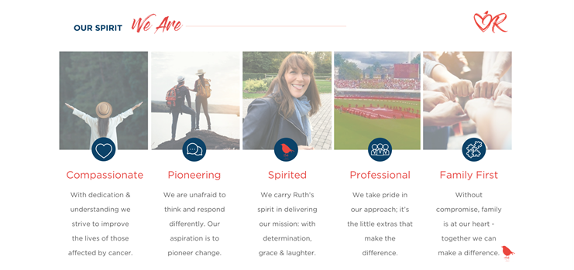

Role overview
To provide operational leadership for safeguarding across the Ruth Strauss Foundation. To lead the Ruth Strauss Foundation in meeting the requirements of the Safeguarding Standards and in keeping with legislation, statutory guidance and RSF Safeguarding Policy.

To recognise and champion that all children, young people, and vulnerable adults at risk are entitled to the same protection regardless of age, disability, gender, race, religious belief, sexual orientation, or identity.

Key relationships
- Strategic Safeguarding Lead
- RSF Executive Team
- Clinical Lead for Family Support Services
- Pre-bereavement Guidance Practitioners (x 2)
- Programme Co-ordinator
- Local Authority Designated Officer
- Service users
- Board of Trustees and Advisory Groups

key responsibilities
Events
- Safeguarding risk assessments for events, embedding this in current risk assessment processes
- Attendance as safeguarding officer at events, support for team meetings with safeguarding considerations, and then a review of each event
- Brief those in attendance at events hosted by the foundation of their duties and responsibilities from a safeguarding perspective
- Safeguarding Considerations for Service Level Agreements when working with third parties to deliver events
- As part of the risk assessment for any events include details of who the LADO is for the event area
Governance
- Keep abreast of policy and legislation changes and best practise informing the charity, Strategic Safeguarding Lead, and senior management of these and advising on the impact and implementation if needed.
- Review and write Safeguarding Policy and processes working with the Strategic Safeguarding Lead
- Review and produce guidance for all employees within the Family Support Service for safeguarding young people, and parents
- Ensure that safeguarding is fully understood by those working with service users, putting measures, processes, and systems in place to protect children and vulnerable adults.
- Be the first point of contact for any safeguarding concerns for all employees/volunteers, ensuring that if not available then this function is passed to an identified person, such as Strategic Safeguarding Lead
- Ensure that any immediate concerns for a service user’s welfare or safety are reported to the relevant public body such as social services or the Police for the service user's area. Including the gathering of information if an incident needs to be reported to the charity commission as decided by Trustees
- Produce monthly reports to the Strategic lead for presentation to Governance Advisory Group and Board of Trustees
- Case Management handling procedure and process
- Maintain a risk register for safeguarding across Mission Service Delivery- in particular, Family Support Service
Training
- Training and support for Youth Groups team on the delivery of peer support groups and is the second person in attendance if required to support the group's delivery.
- Deliver Safeguarding training to all employee’s dependent on the role with specific training for counsellors working with children and teenagers. Ensuring that records are kept, and the training is regularly refreshed. No staff should undertake service delivery with clients without this training. Review training is previously done by staff to check if it is relevant, transferable, and recording if training does not need to be repeated
- Working with the Strategic Safeguarding Lead to deliver annual updates and significant changes to all employees, Board and Advisory Group on safeguarding
- Proactively delivering messages of how to share a concern for employees, parents, and young people
- Testing process and systems and training for identifying, sharing and /or dealing with a safeguarding concern
Operational
- Be the first point of contact for People managers (aka line managers) on any safeguarding concerns
- Review all concerns/reports asap and make a clear assessment of whether the information received is deemed to be a child/adult protection referral, and/or a situation in which further action must be taken
- Support guidance on safer recruitment working with People manager/People Lead (once recruited)
- Based on Advice from Strategic Safeguarding Lead implement a process for gaining DBS checks for all staff that require this and ensure these are reviewed as required
The list of responsibilities is not exhaustive and as this is a new service, the role is likely to evolve.

Person specification
essential
- Professional experience of safeguarding gained through relevant undertaking and management of casework e.g., Police, Social work, Education, including an understanding of current relevant legislation, best practices and national framework for safeguarding and promoting the welfare of children.
- Understanding of local and national arrangements for managing safeguarding children and reporting procedures.
- Experience in building relationships with key stakeholders.
- Experience in working to high levels of confidentiality including the storage of confidential documents.
- Enthusiasm and commitment to safeguarding.
- Ability to challenge poor practice and effect change.
- Presentation and training skills
Advantageous
- Experience in Multi-Agency working.
- Experience of volunteering or working in the charity sector, sports, or similar activity.
We are committed to being an inclusive workforce that fully represents many different cultures, backgrounds, and viewpoints. We welcome applications that help us in our mission to be a place where you can be yourself and thrive.
To apply please email your CV and one single A4 document as to 'How your skills and experience meet our requirements to recruitment@ruthstraussfoundation.com by 20th August 2022.
We intend to interview shortlisted applicants informally via zoom on the 22nd of August 2022 followed by a face-to-face interview on the 31st of August 2022, competency based, at Lord’s Cricket ground.
Please Email recruitment@ruthstraussfoundation.com if you would like to discuss the role further before making an application.

